PHASE 2 – REQUIREMENT ANALYSIS
Introduction:
- The Requirement Analysis phase identifies the requirements needed to implement the automated standard laptop procurement process.
- The project is designed to use ServiceNow Flow Designer to automate the creation and assignment of a Cata log Task after a Standard Laptop request receives the required approval.
- The requirements identified in this phase are based on the project problem statement, user story, objectives, and workflow described in the project reference document.
Existing Process:
- In the existing standard laptop procurement process, manual activities may be required after a user requests a laptop. The configuration task may need to be created and assigned manually to the appropriate team.
- This can result in delays, additional manual work, and the possibility of the configuration activity being overlooked.
- Therefore, an automated process is required to improve the handling of standard laptop requests.
[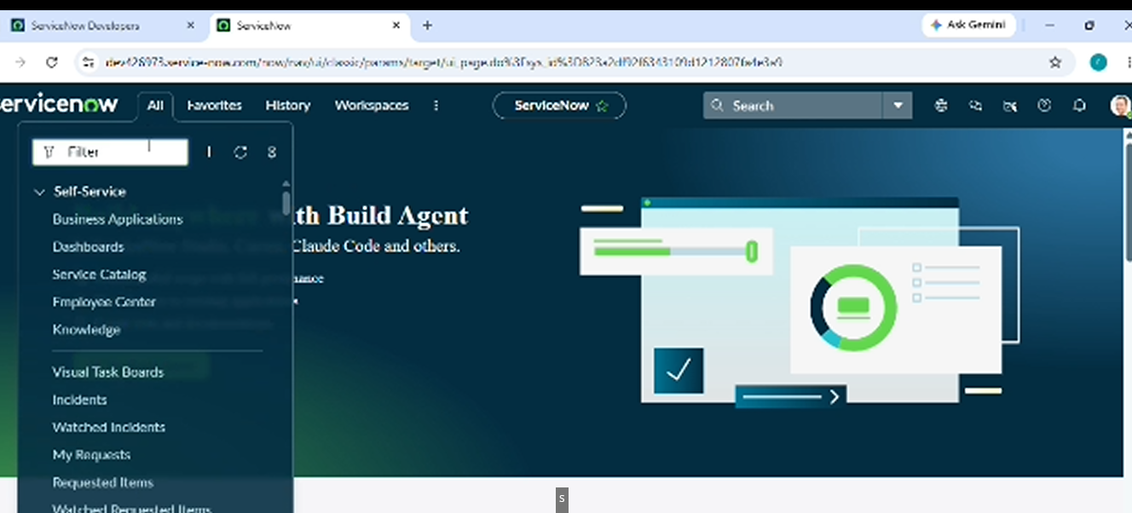
Functional Requirements:
- The functional requirements describe what the system should perform.
The main functional requirements of this project are:
1. The system should provide a Standard Laptop service Cata log item.
2. A user should be able to place a Standard Laptop order through the Service Cata log.
3. The Standard Laptop request should go through the required approval process.
4. After the request is approved, the Flow should be triggered.
5. The Flow should automatically create a Cata log Task.
6. The Cata log Task should contain the required short description
7. The Cata log Task should be assigned to the Hardware assignment group
8. The generated task should be available for the Hardware team to process.
T 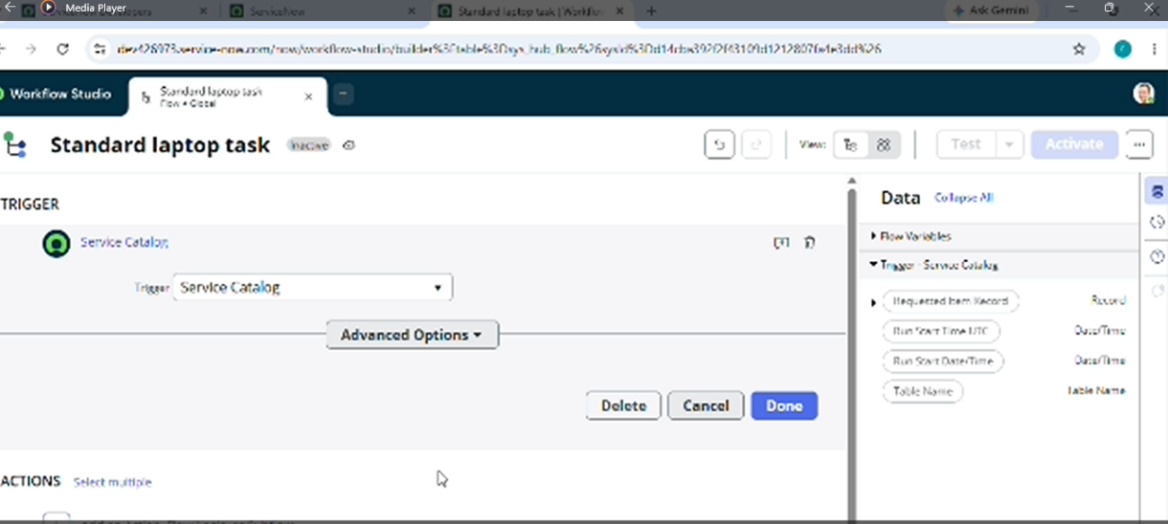
Flow Requirements:
The Flow Designer workflow requires the following major elements:
1.Trigger
The Flow should use a Service Cata log trigger.
2.Action
The Flow should use the Create Cata log Task action.
3.Requested Item
The requested item record should be used for creating the Cata log Task.
Short Description:
The Cata log Task should contain the short description:
“Laptop need to Configured”
Assignment Group:
The Cata log Task should be assigned to:
    - Hardware
    - Approval
The task creation process should be associated with the required approval condition:
1.Approved
- These requirements form the main configuration of the Flow Designer workflow.
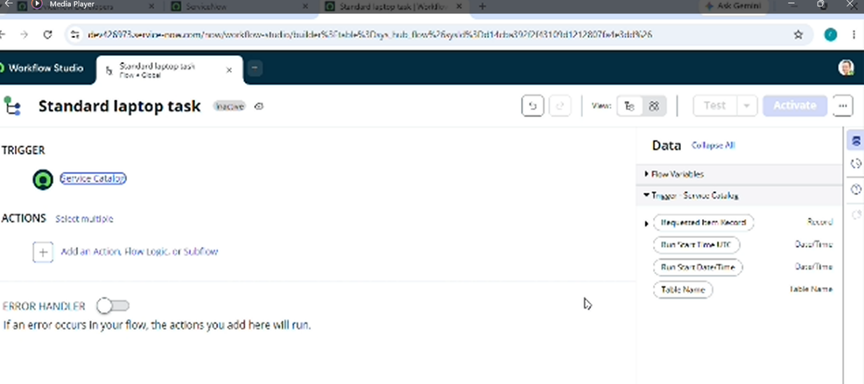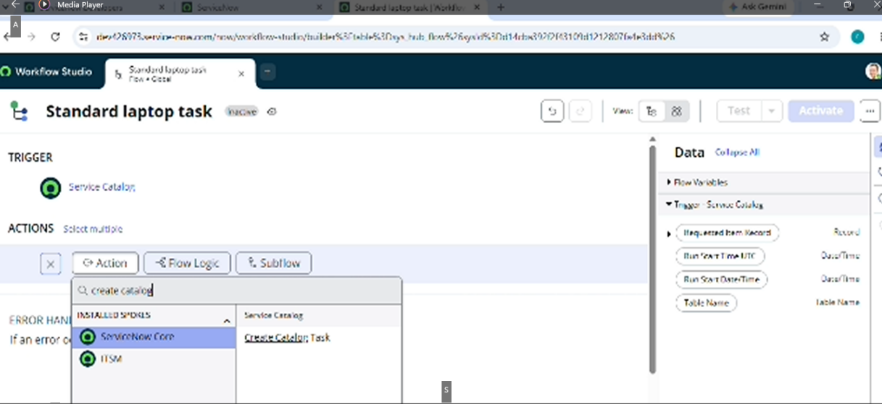
ServiceNow Platform Requirements:
The project requires the following ServiceNow platform features:
- Flow Designer – to create and automate the workflow.
- Service Cata log – to allow users to place the Standard Laptop request.
- Maintain Items – to configure the Standard Laptop service Cata log item.
- Cata log Task – to create the task required for laptop configuration.
- Hardware Assignment Group – to receive the generated configuration task.
- Approval Process – to ensure the request is approved before the task is created.
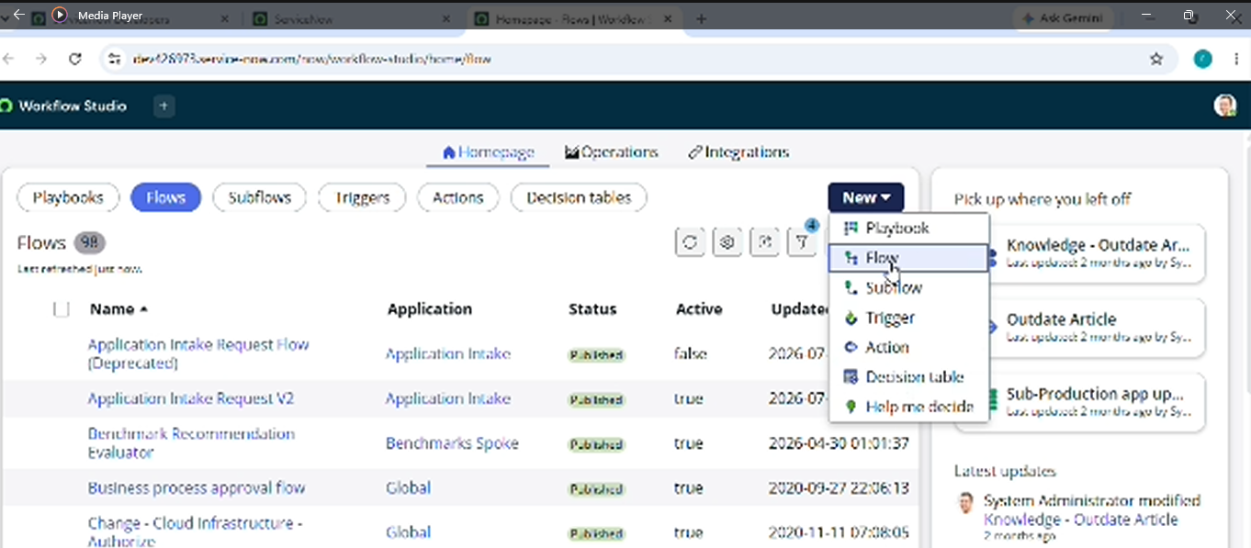
Input Requirements:
- The main input to the process is a Standard Laptop request submitted through the Service Cata log.
- The request must proceed through the required approval process. Once the request is approved, the Flow Designer automation should create the required Cata log Task.
The basic input process is:
Standard Laptop Request → Approval
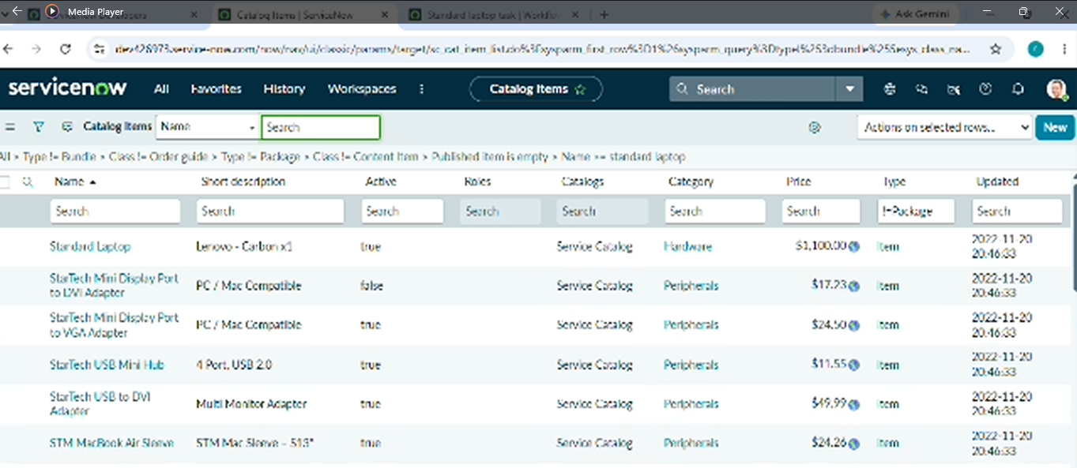
Output Requirements:
- The expected output of the automated process is a Cata log Task created for the Hardware team.
The generated task should contain:
- Required Cata log Task record
- Short description: Laptop need to Configured
- Assignment group: Hardwar
- Appropriate approved request information
The output can be checked from the Requested Item → Cata log Tasks section.
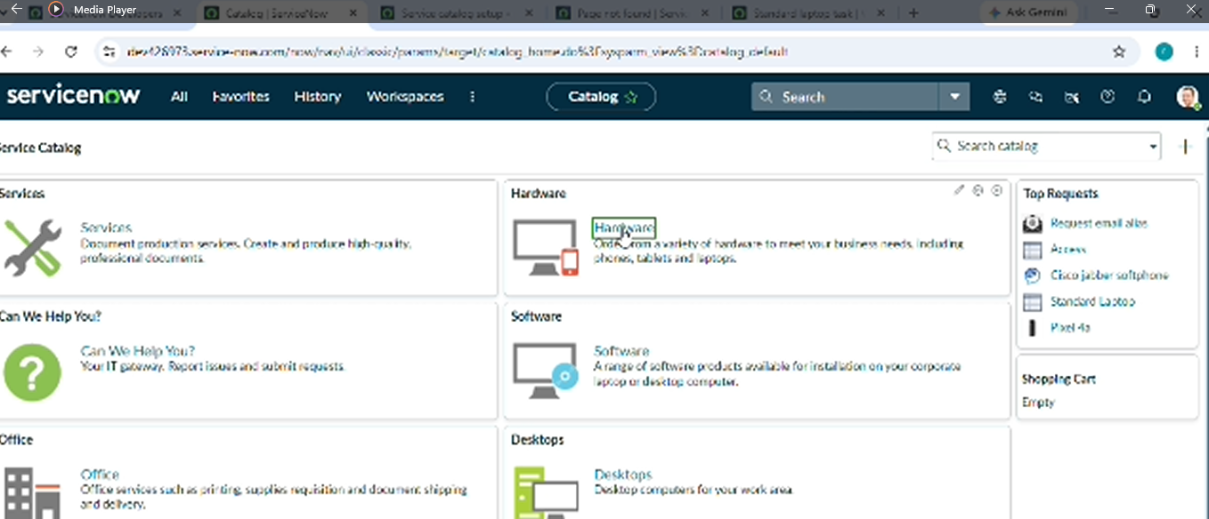
Requirement Flow:
The overall requirement flow can be represented as:
Standard Laptop Request
↓
Request Approval
↓
Service Cata log Trigger
↓
Create Cata log Task
↓
Short Description Added
↓
Assignment Group – Hardware
↓
Hardware Team Processes Task
This flow represents the required behaviour of the project.
Requirement Summary:
- The Requirement Analysis phase identifies the requirements needed for automating the Standard Laptop procurement process.
- The system should allow a Standard Laptop request to be placed through the Service Cata log. After the required approval is completed, ServiceNow Flow Designer should automatically create a Cata log Task with the required short description and assign it to the Hardware group.
- These requirements provide the basis for designing and developing the automated workflow in the next phases.
The recommended screenshot locations are:
1. After Existing Process – Standard Laptop request screen.
2. After Functional Requirements – Standard Laptop Service Cata log screen.
3. After Flow Requirements – Flow Designer Trigger and Create Cata log Task screens.
4. After ServiceNow Platform Requirements – relevant ServiceNow module screen.
5. After Input Requirements – Standard Laptop order/request screen.
6. After Output Requirements – Requested Item / Cata log Tasks screen.
Table Requirement:
- A table is not compulsory for Phase 2 based on the reference document.
- The reference document mainly explains the project requirements and the Flow configuration through step-by-step instructions. Therefore, Phase 2 can be prepared using headings, paragraphs, bullet points, and relevant screenshots without adding a table.
- If your college/Smart Bridge specifically asks for a Requirements Table, one simple table.
Suggested columns:
Requirement | Description
Standard Laptop Request | User should be able to order a Standard Laptop
Approval | Request should receive the required approval
Flow Trigger | Service Cata log trigger should start the Flow
Cata log Task | Flow should automatically create a Cata log Task
Short Description | Laptop need to Configured
Assignment Group | Hardware

Phase 2 Summary:
- The Requirement Analysis phase defines the functional and platform requirements for automating Standard Laptop procurement.
- The main requirement is that an approved Standard Laptop request should automatically generate a Cata log Task through Flow Designer and assign the task to the Hardware group.
- The identified requirements will be used in the Project Design Phase to define the detailed workflow structure.

